**Project on E-Fixed Deposit of Agile Scrum**

Q1) Make a product backlog of user stories for the given case study. User Stories should be in the format of As a <type of user>, I want <goal> so that <reason>

Ans) The Product backlog of user stories for E-Fixed Deposit are mentioned below:

1. As a user, I want login page of ABC Bank shall have labels of username and password along with two text fields as well as login and Register as new user button so that user can successfully login inside the ABC Bank
2. As a user I want My Accounts label has to be visible on the first page of ABC Bank so that customers can view the Total Balance, Credit Cards,Loan Types and E-Fixed Deposit in drop down
3. As a user,I want My Accounts label has to be red in colour and clickable so that it display the Total Balance, View Bank Statements and new Deposit Creation in a drop Down
4. As a user, I want credit cards label has to be underline and black in colour so that it can show the various credit card types in a drop down
5. As a user, I want Loans Label has to be underline and black in colour so that it will display the various loan types in drop down
6. As a user, I want E-Fixed Deposits has to be clickable and black in colour so that it display the FD Maturity Amount in the drop down

These are some of the epics of the E-Fixed Deposit

1. Login-Page
2. Accounts Page
3. My Accounts Drop Down
4. Credit Cards
5. Loans
6. E-Fixed Deposits

The below mentioned are the screenshots of the epics and product backlog user-stories

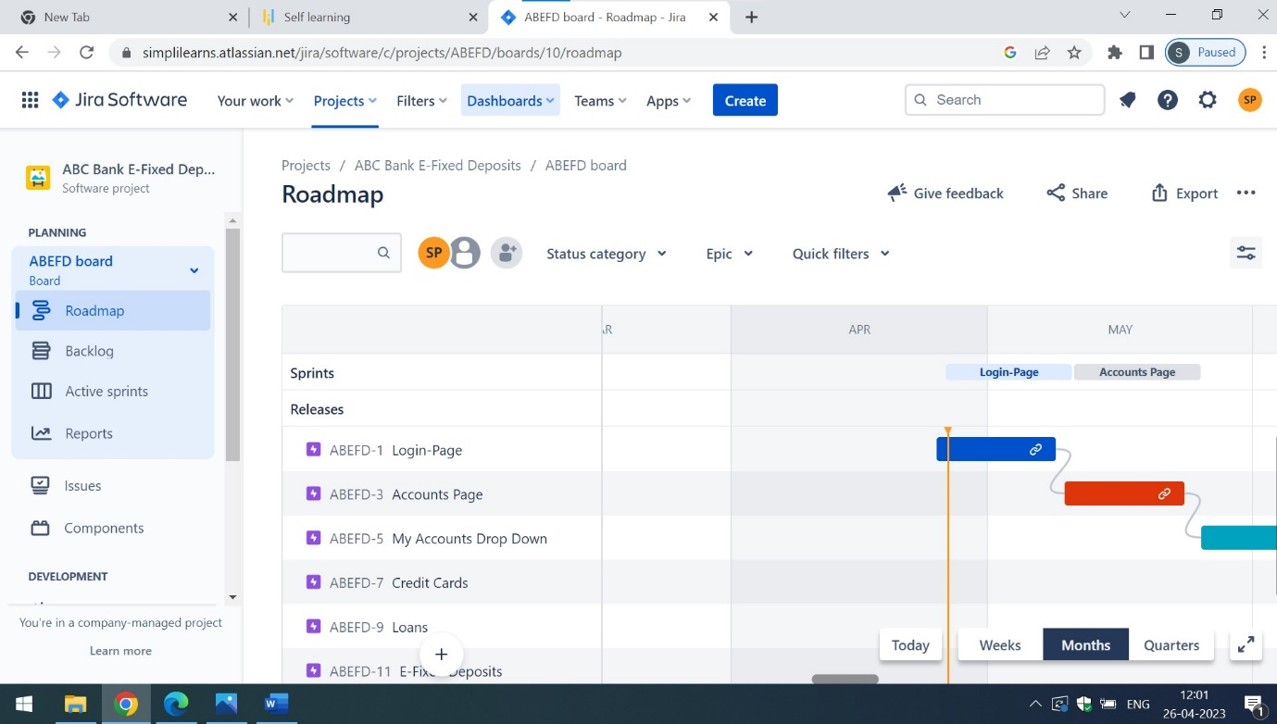

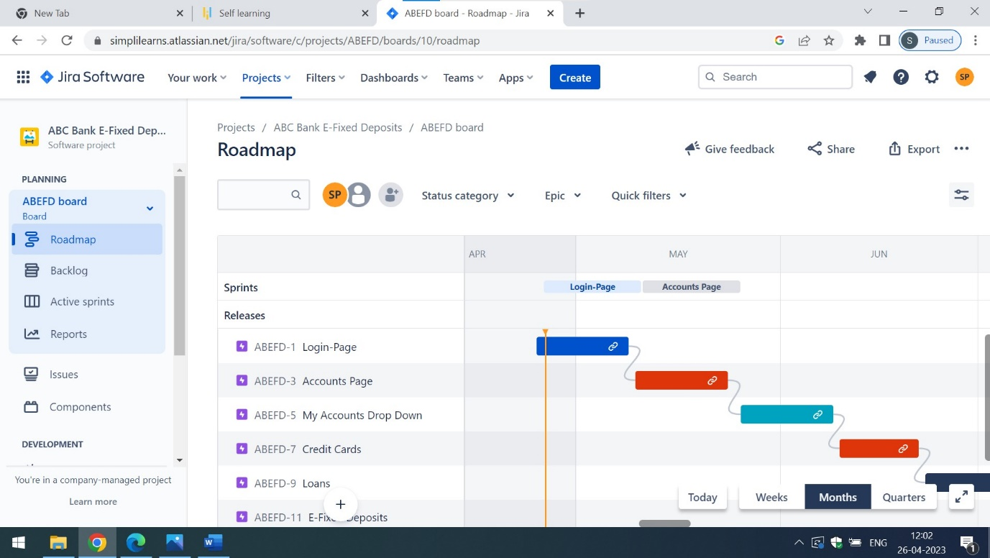

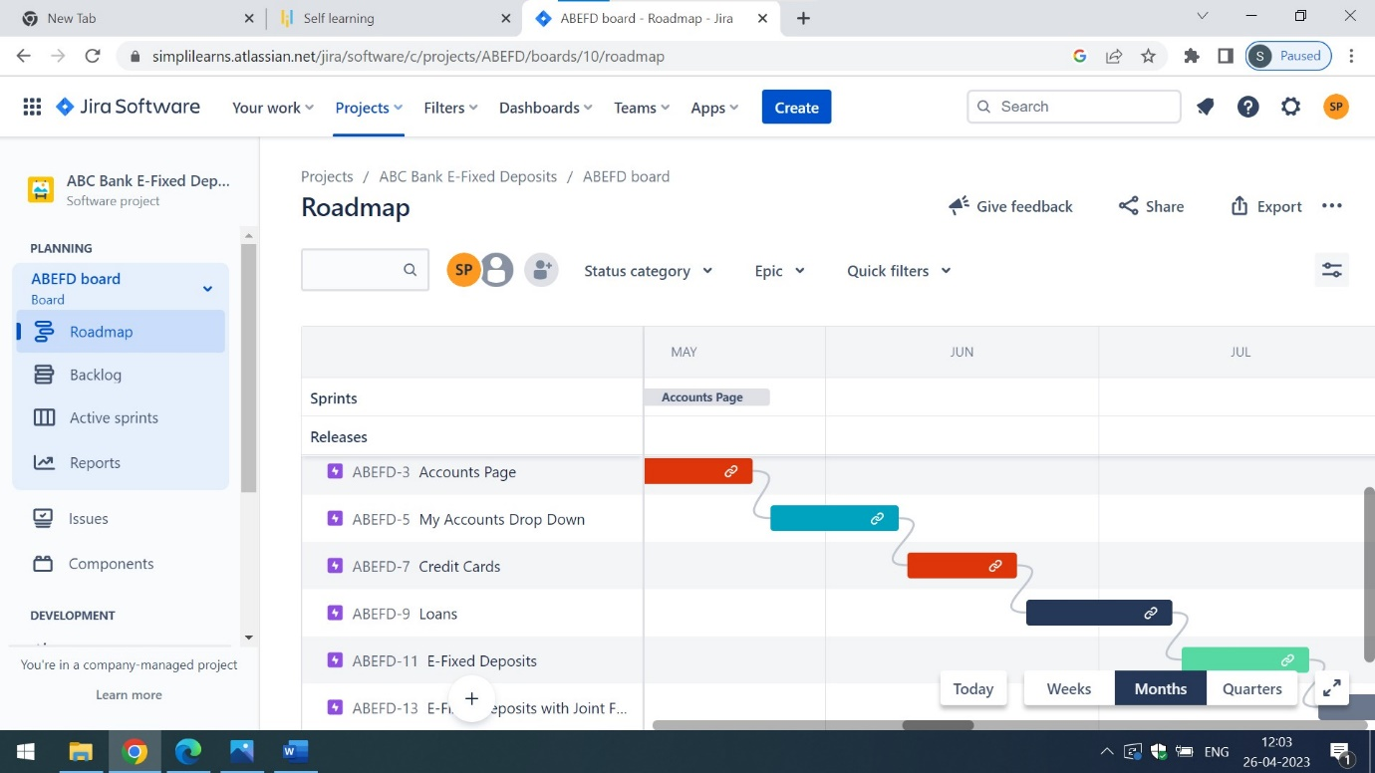

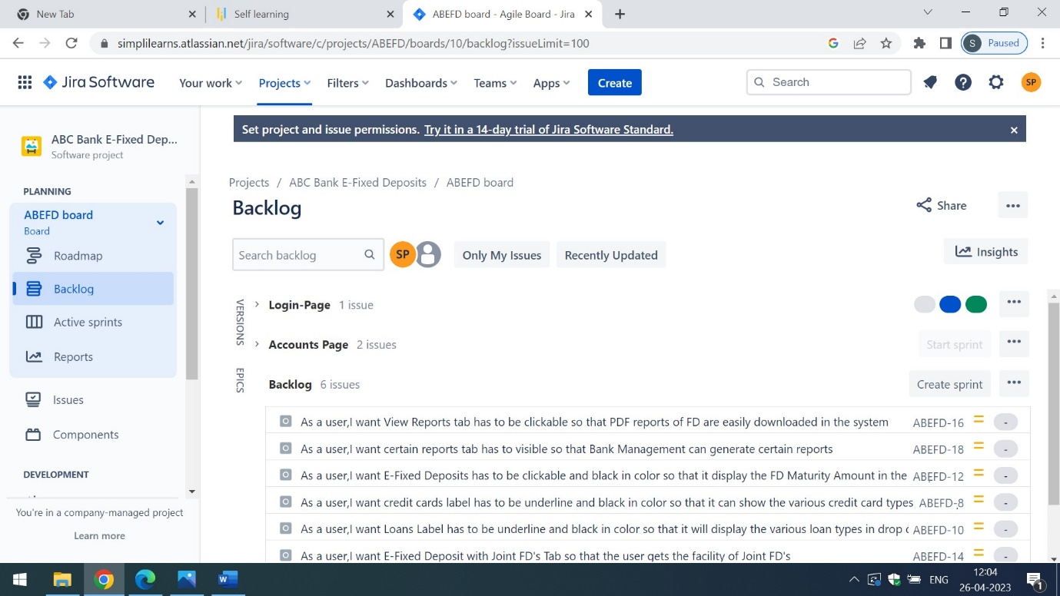

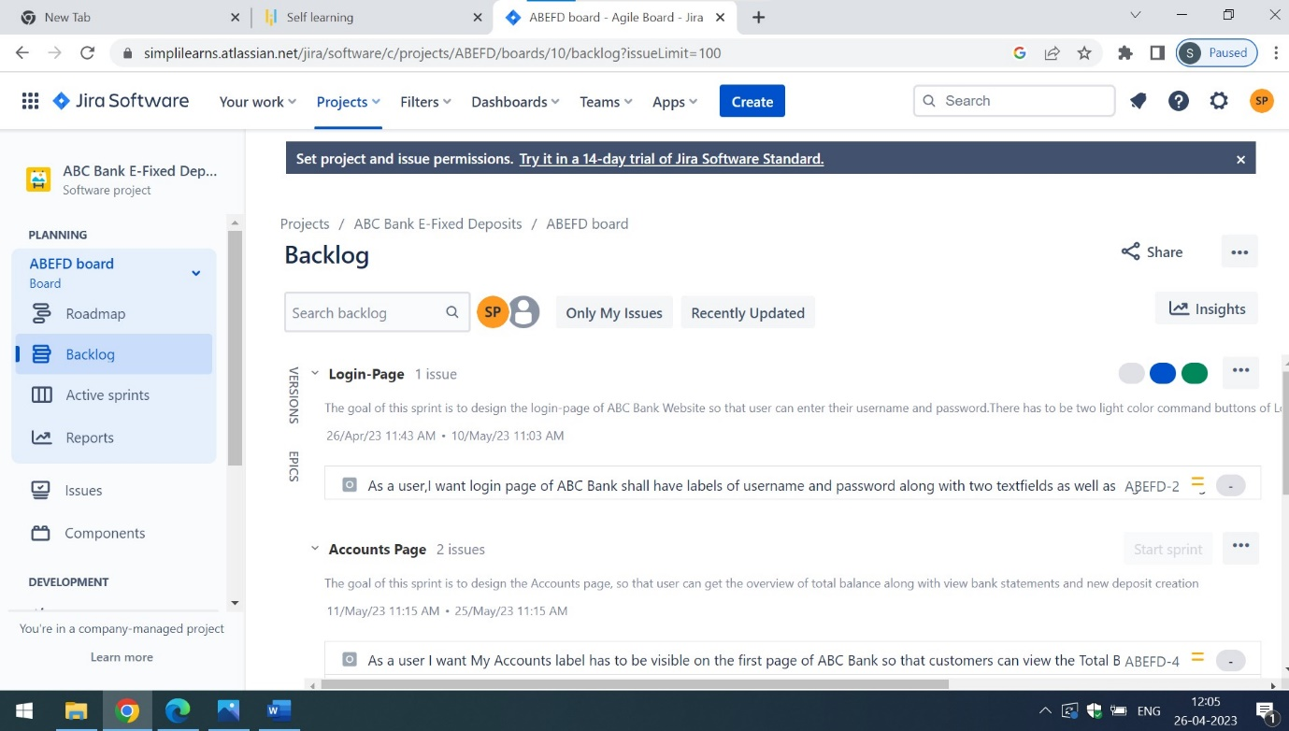

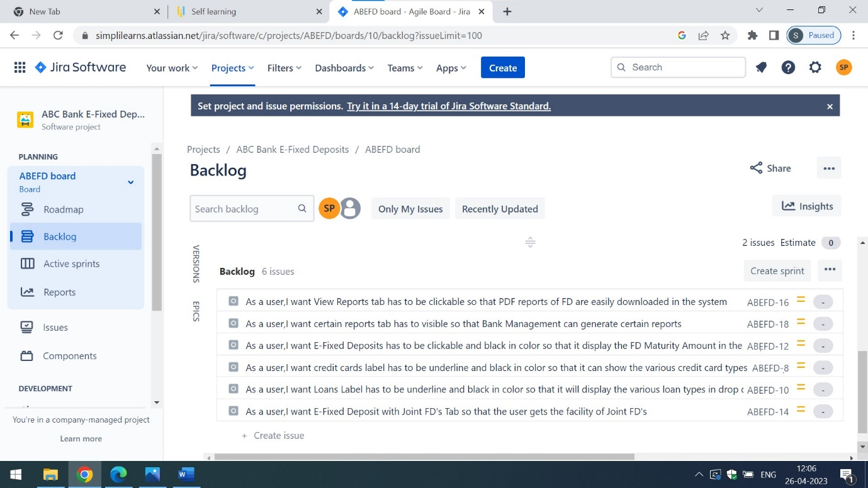

Q2) For each story, write the acceptance criteria

Ans) These are the **acceptance criteria of login-page**

a) User Must be able to click on login and register as new user buttons

b) The colour of login and register as new user button has to be light blue in colour

c) When the user types the password in the password text box, it has to be represented in * format

d) If the username exists previously in the database, then the textbox must display the warning message while typing the username in the username text field

e) The text field of username must display the right symbol in green colour if it accepts the username

f) The text field of password must display the right symbol in green colour if it accepts the password

These are the **acceptance criteria of Accounts Page**

a) The label of My Accounts has to be underline and black in colour

b) When the user clicks on My Accounts, it must display My Accounts,Credit Cards,Loans and E-Fixed Deposit in a scroll bar view

c) All these options present under My Accounts has to be clickable

These are the **acceptance criteria of My Accounts Drop Down**

1. My Accounts label must be red in colour and must be visible inside the combo box
2. When the customer clicks on My Accounts, it should display the Total Balance in USD,Show Balance with an on-off switch and view bank statements
3. There has to be label of Recharge Now which is placed at the right side of phone symbol, send money label with double arrow symbol and start a new deposit label with start new command button in light green colour

These are the **acceptance criteria of Credit Cards Page**

a) The Credit Cards text has to be underline, clickable and black in colour

b) The Credit Cards must include the Travel,Fuel,Shopping,Rewards,Business and Students credit card categories in the drop down

c) User must be able to select at most three credit cards based on their personal and financial information such as name,gender,occupation,mobile no,email,Gross Monthly Income and Mortgage Payment Monthly

These are the acceptance criteria of Loan Page

a)The Loans label must be underline and black in colour

b) When the user clicks on loans, it must display the various loan types such as Home,Gold,Student and Vehicle in loan categories

c) User must be able to select various loan types based on KYC,Monthly Income and Credit Score

These are the **acceptance criteria of E-Fixed Deposit**

a)The E-Fixed Deposit has to be underline and black in colour

b) When the user clicks on the E-Fixed Deposit it must open the browser window with ABC Website with E-Fixed Deposit as header in the browser window

c) There has to be a logo of ABC which must be visible to the user

d) For opening the Fixed Deposit,user must enter the Savings Account Number in the Text Box

e) There has to be a label of Savings Account Number associated with yellow text box, Account Balance associated with yellow text box,Type of Fixed Deposit with Tax Savings,Special Fixed,Regular Income,Senior Citizen,Flexi Fixed and Corporate Fixed in a combo box menu

f) There has to be a label of FD Calculator associated with a text area

g) The text area of FD Calculator shall contains the label of age,amount for FD Creation and Maturity Amount associated with white text boxes

h) There has to be a yellow submit button placed under the amout of FD Creation label

i) User shall be able to select one option from renew fd for same tenure and Credit Maturity Amount to my Savings or Current Account which is attached with Maturity Instructions for FD Label

j) There has to be a label of Mobile Number associated with white text box and email id with white text box outside the text area of FD Calculator

k) There must be a link of Update email id

l) There has to be a checkbox with I have read the terms and conditions of Joint FD creation for ABC Bank Caption

m) There has to be two yellow command buttons with submit and cancel caption

These are the acceptance criteria of E-Fixed Deposit with Joint FD’s

a)When the user clicks on Joint FD’s Tab,it shall ask for the name of the nominee for new users of ABC Bank

b) For existing users of ABC Bank,it must display the name of the nominee

c) There has to be a label of name of the nominee along with white text box

These are the **acceptance criteria of View Reports section:**

a) The View Reports tab has to be underline and black in color

b) When the user clicks on view reports,it must open the PDF files of FD which are easily downloadable in the system

c) There has to be a checkbox with Email Pdf copy of FD caption

d) When the user clicks on the above checkbox, they should be emailed a PDF copy of FD

These are the **acceptance criteria of Certain Reports Tab**

a) Certain reports section has to be visible for ABC Bank Management only. This certain reports section is not visible to any alternate Bank Management and even to ABC Bank Customers and employees

b) When the Management of ABC Bank clicks on Certain reports,it shall generate the following options in a drop down view. The options are listed below

* Total value of FDs for users with tenor of less than 6 months.
* Total value of FDs for senior citizens with tenor of less than 6 months.
* Total value of FDs for users with tenor of between 6 months 1 day and 1 year.
* Total value of FDs for senior citizens with tenor of between 6 months 1 day and 1 year.
* Number of FDs that are more than 1.5 Million USD for normal users.
* Number of FDs that are more than 1.5 Million USD for senior citizen users.

c) All the above-mentioned options has to be clickable and must generate the PDF view in separate browser

Here are the screenshots attached of the acceptance criteria:

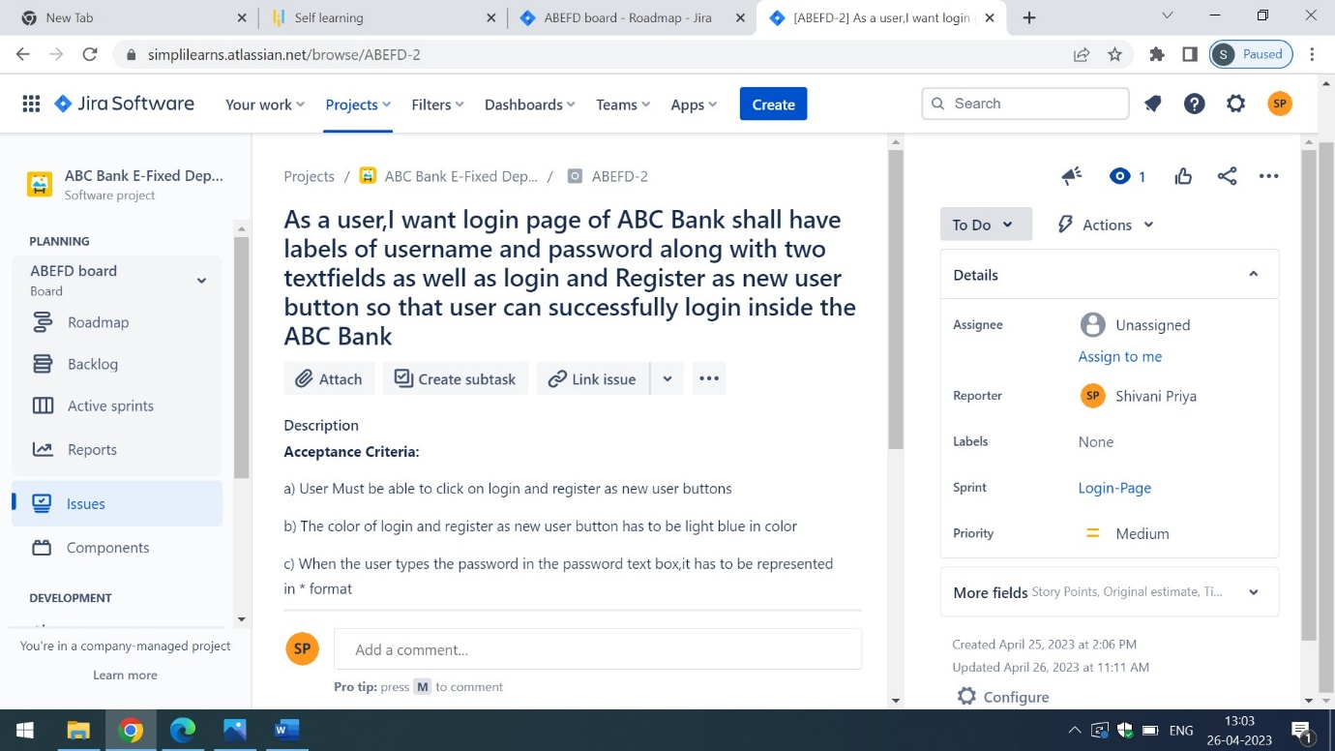

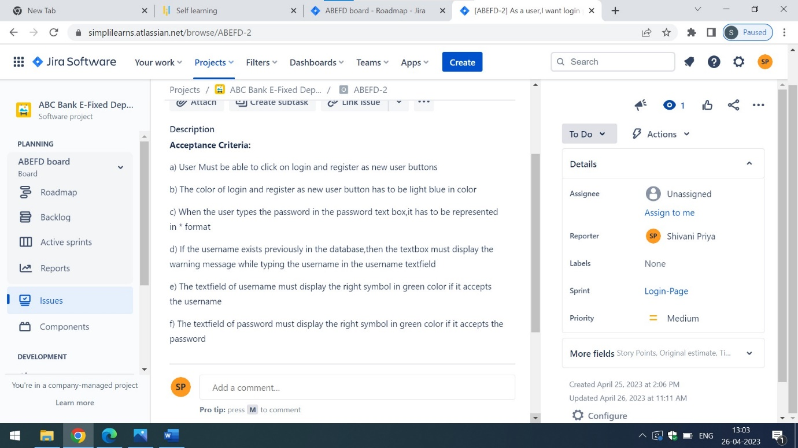

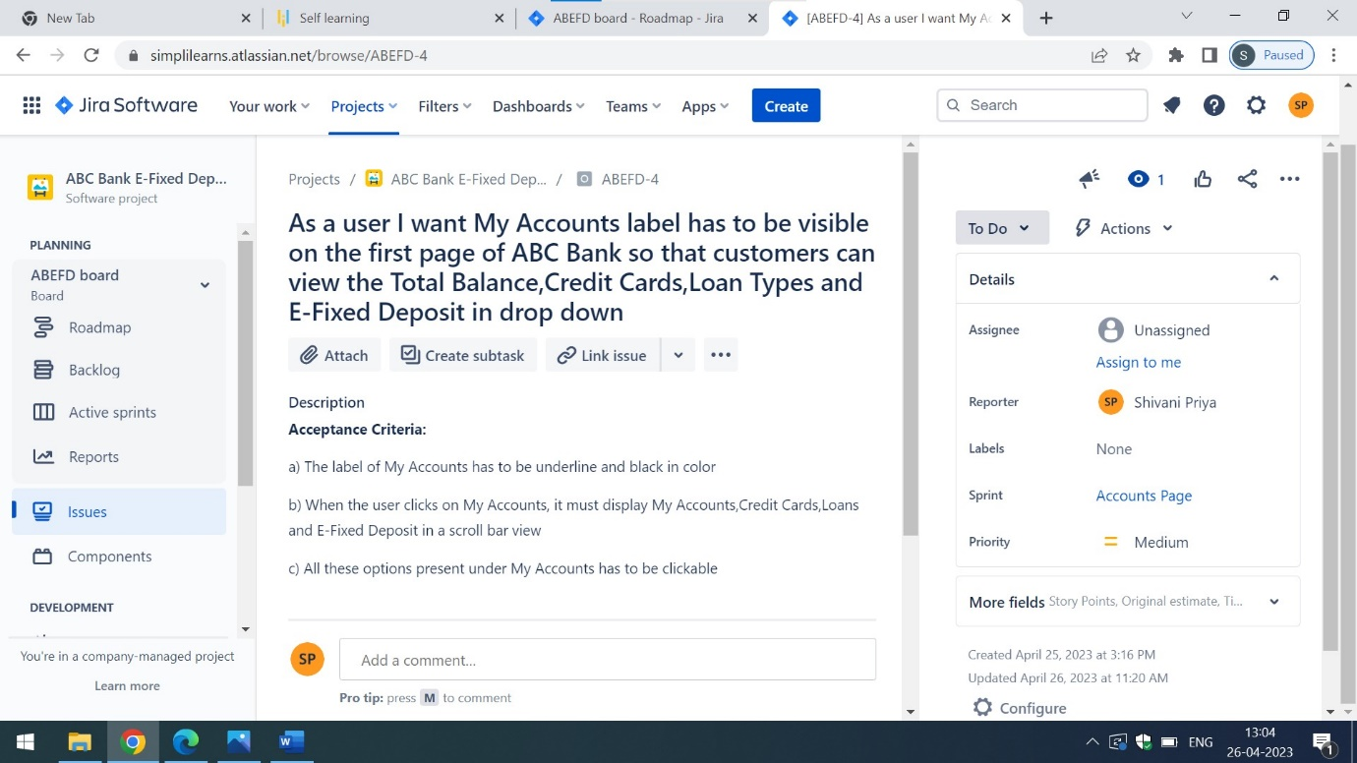

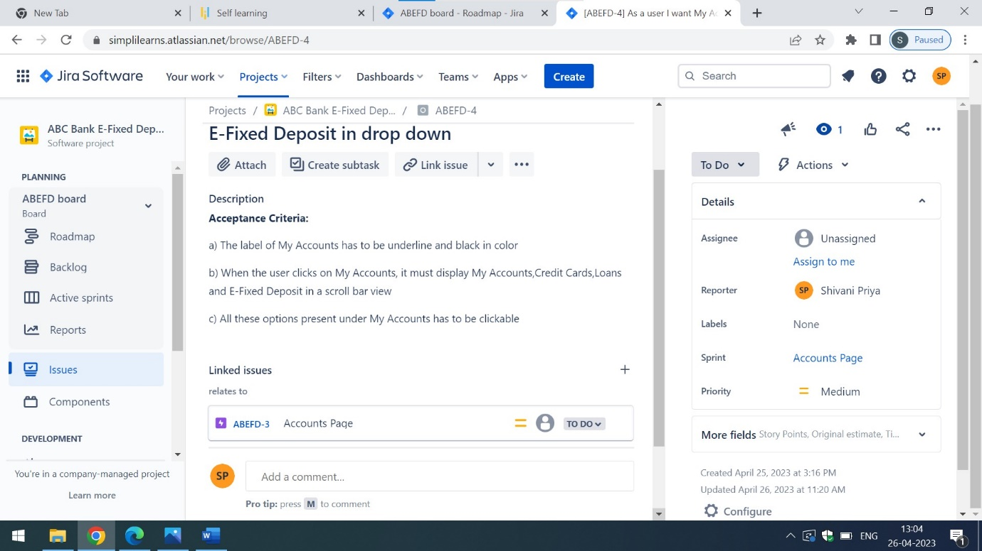

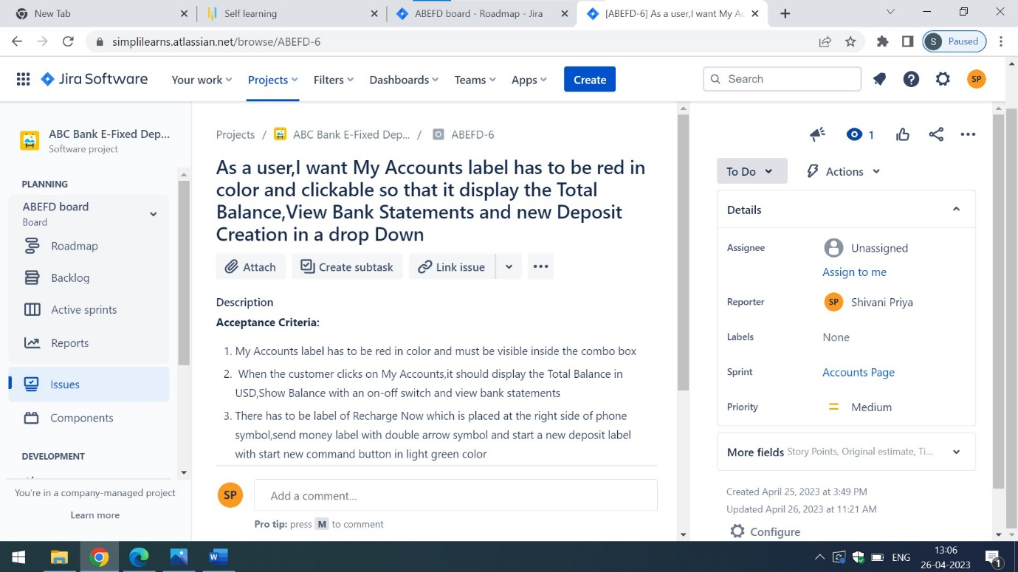

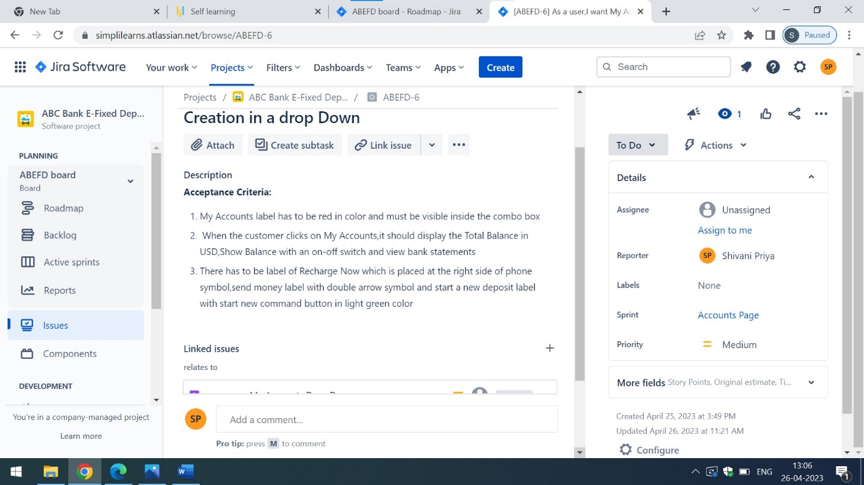

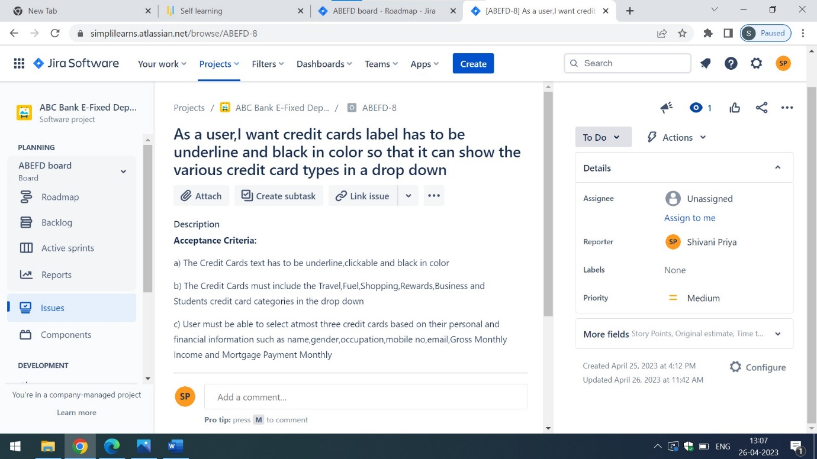

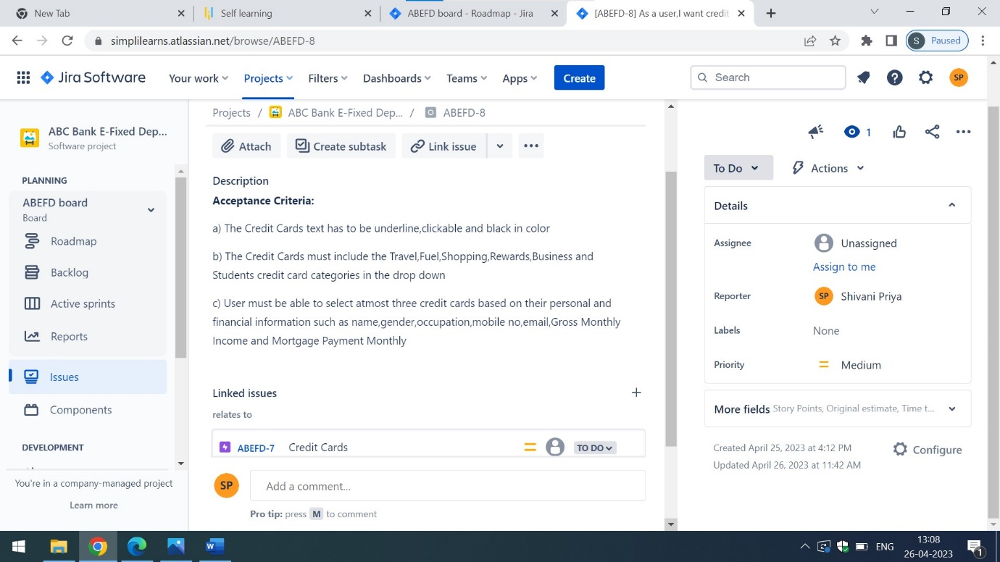

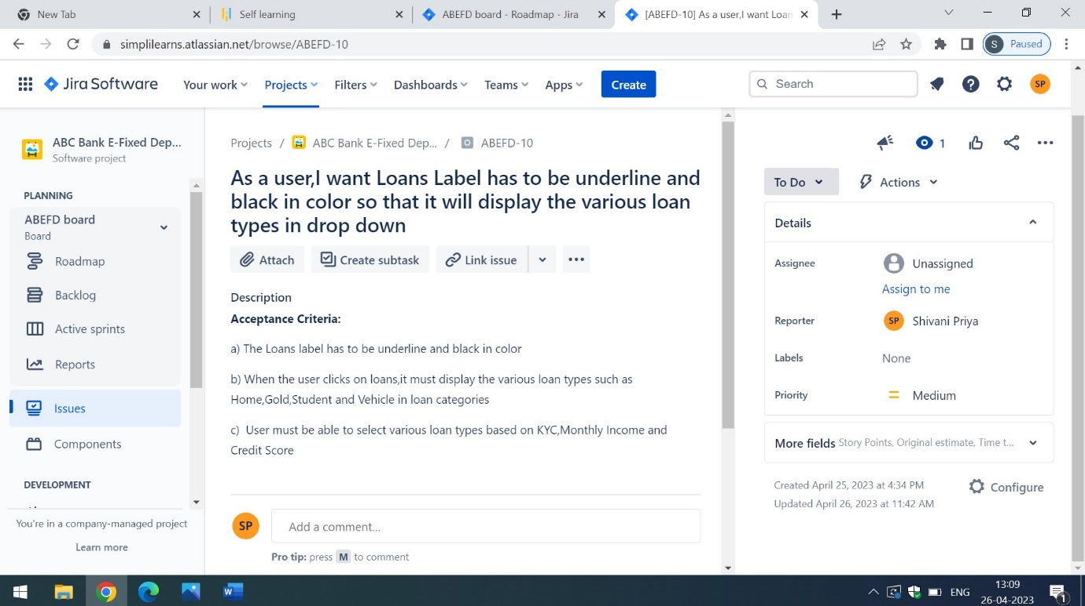

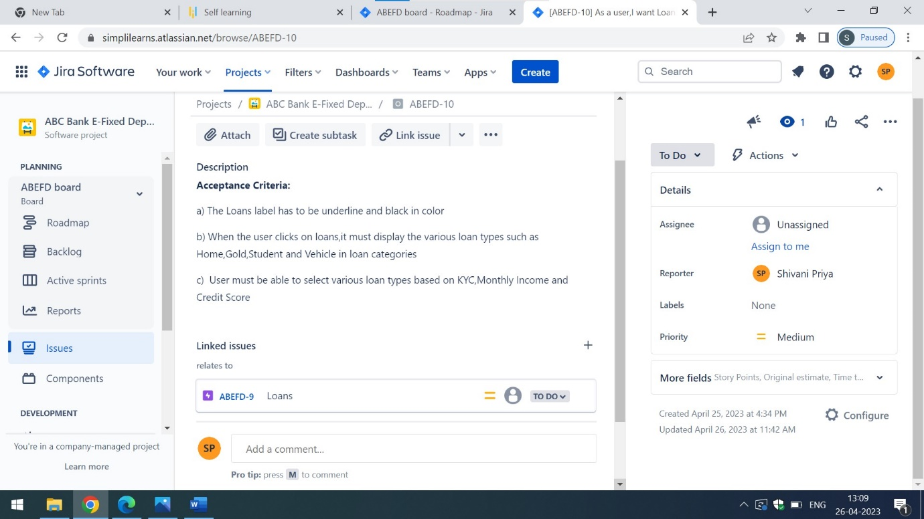

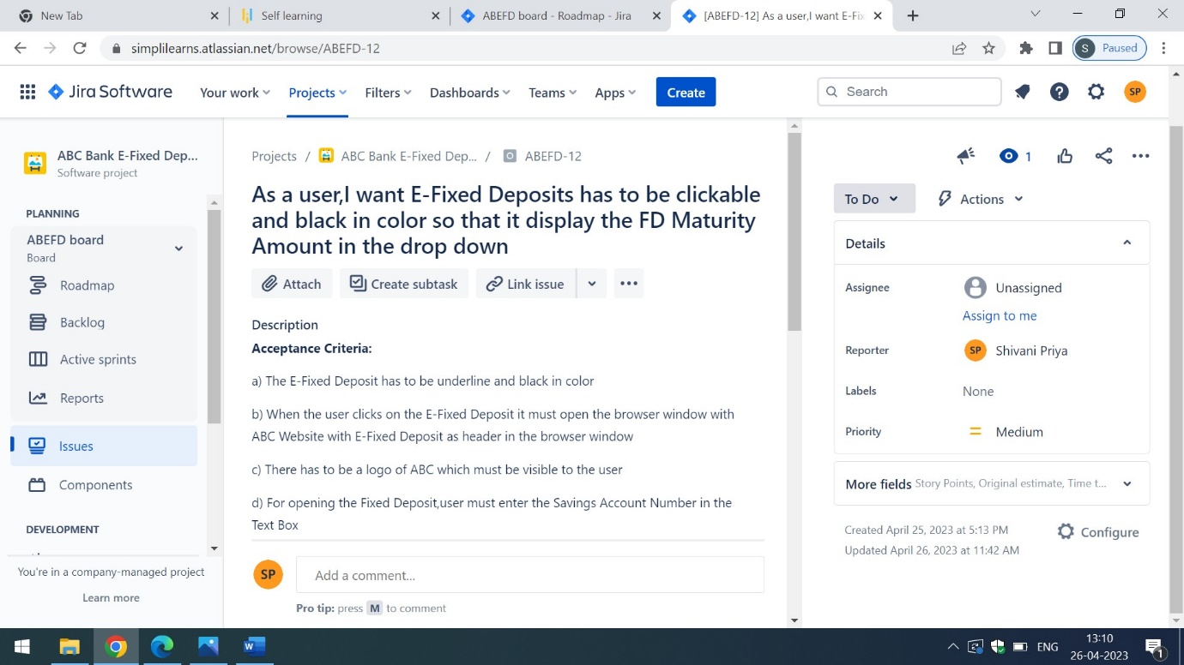

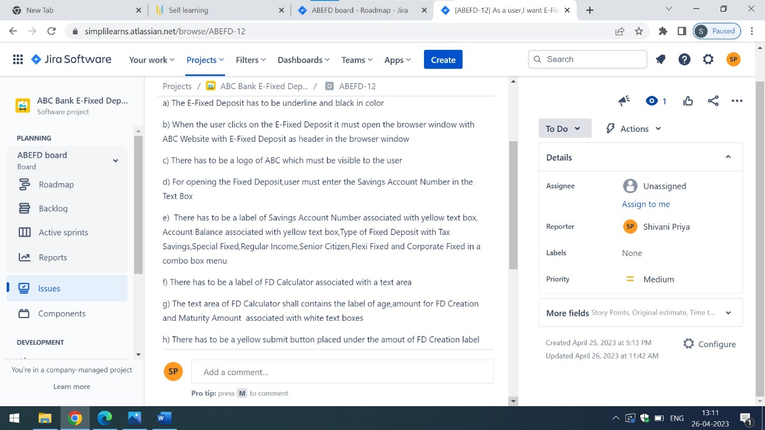

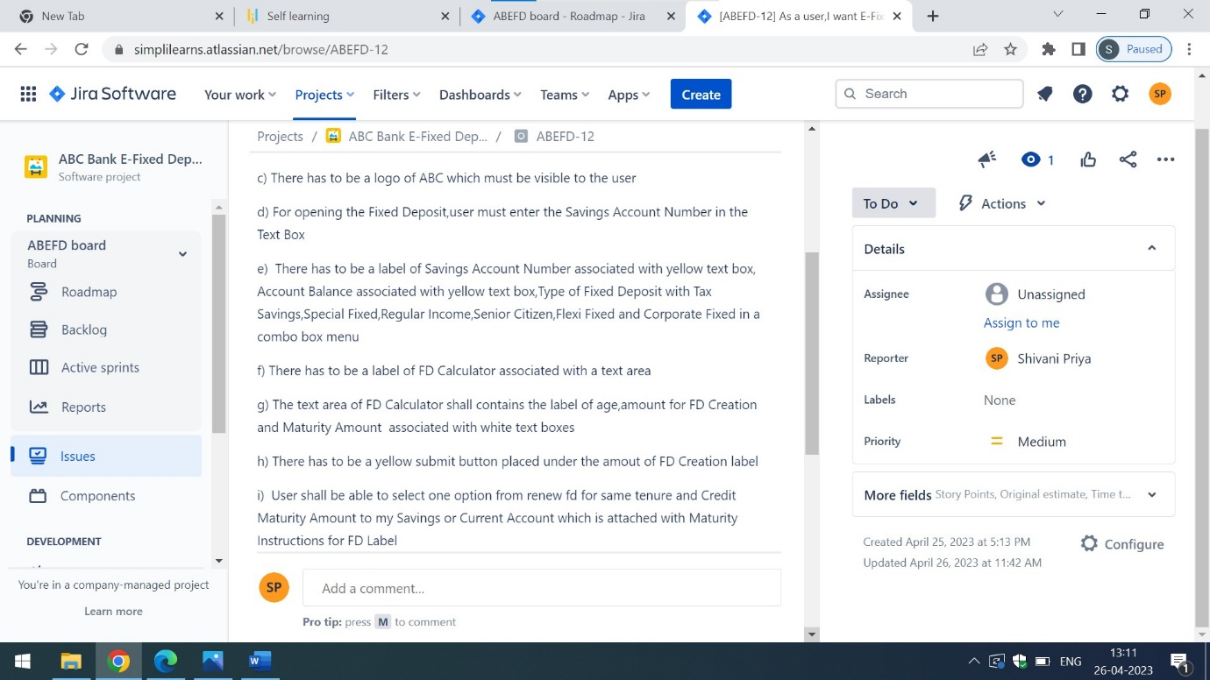

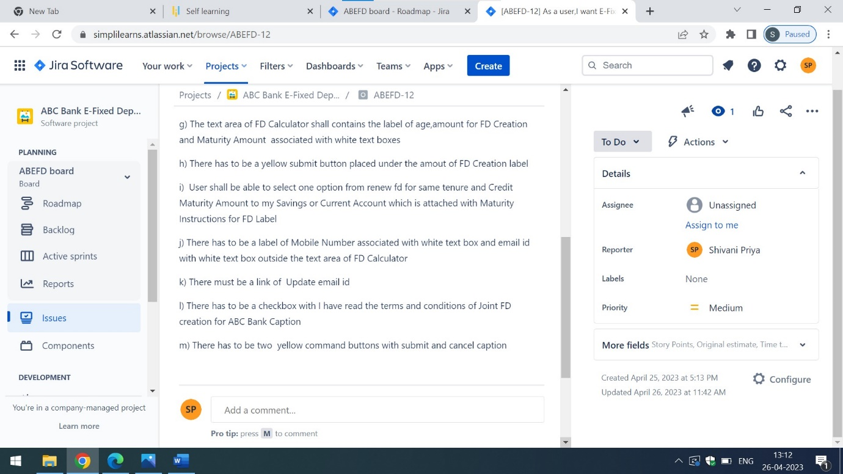

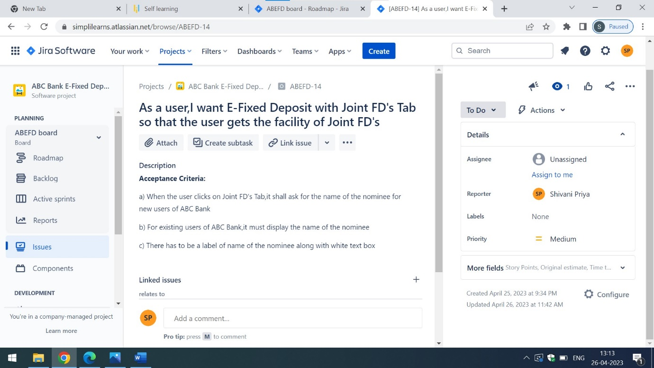

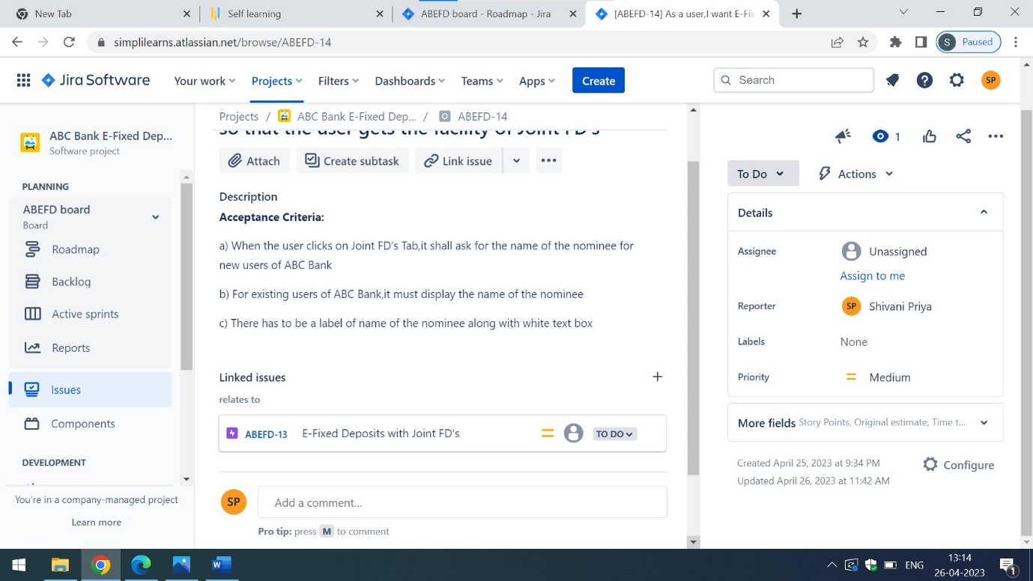









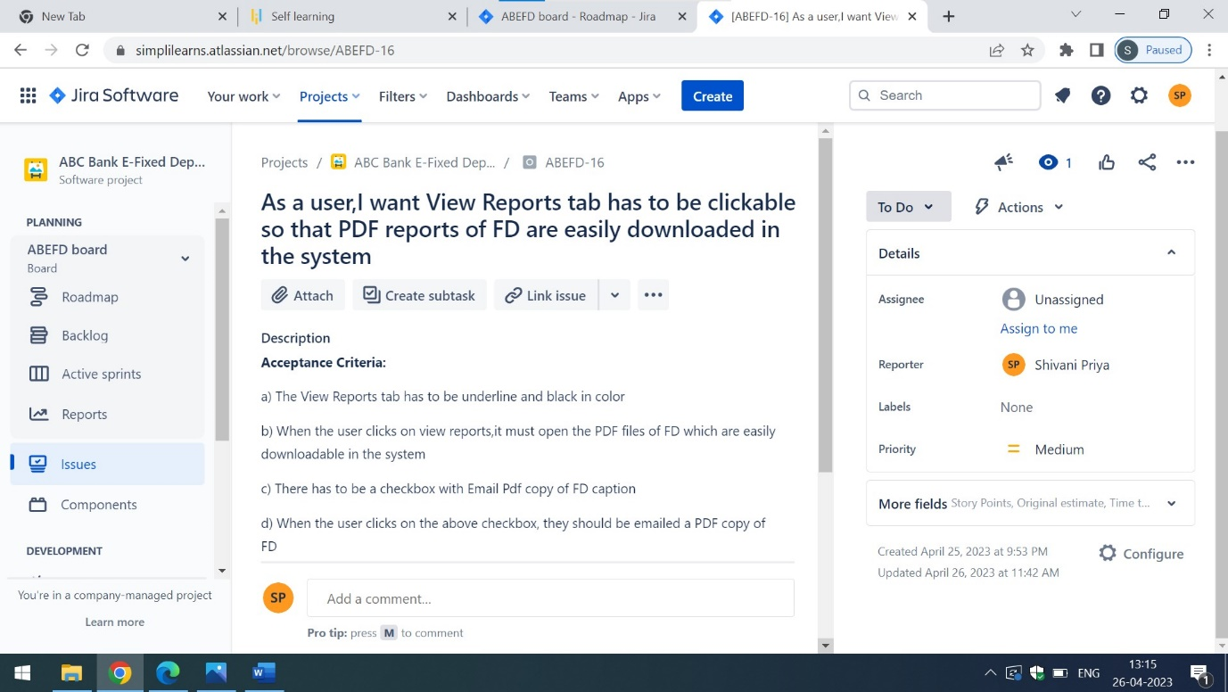

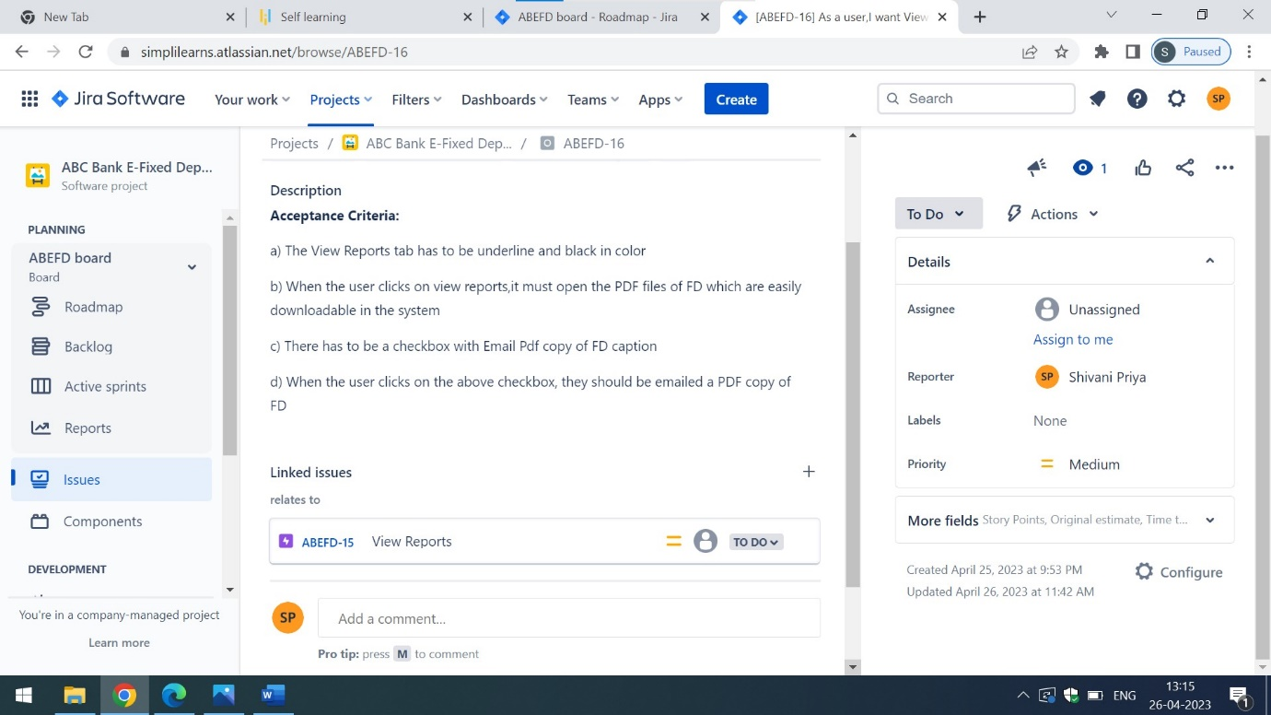

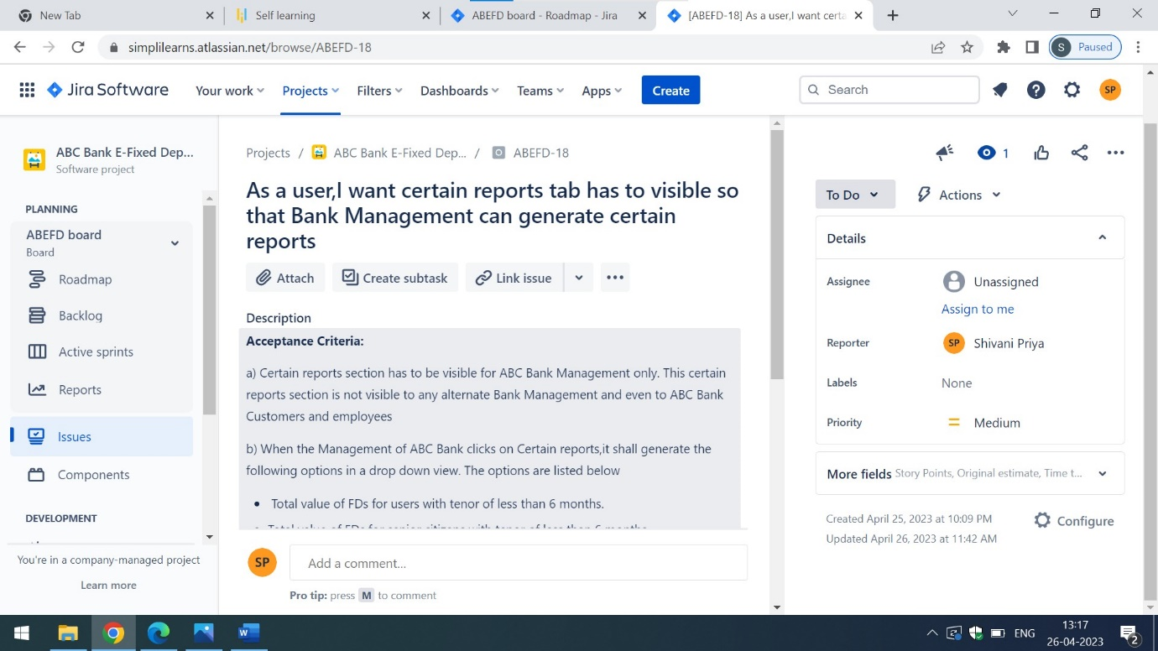

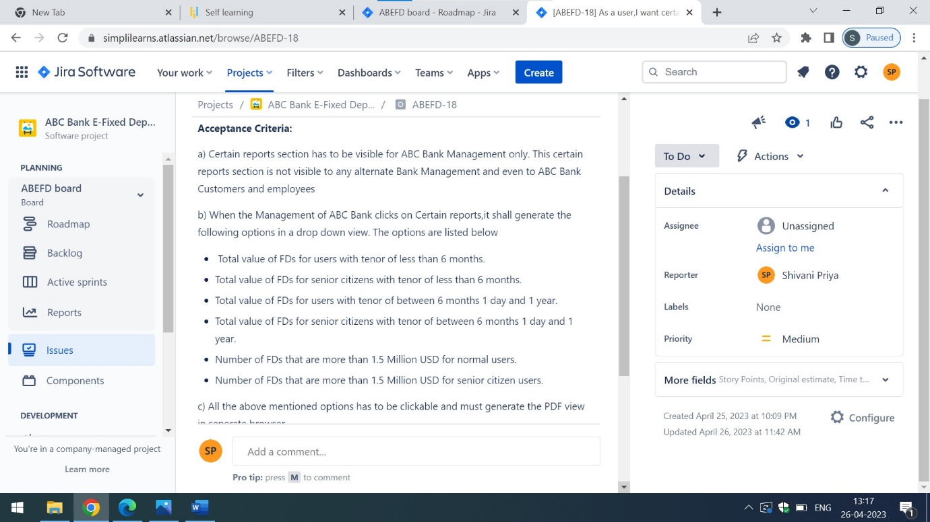

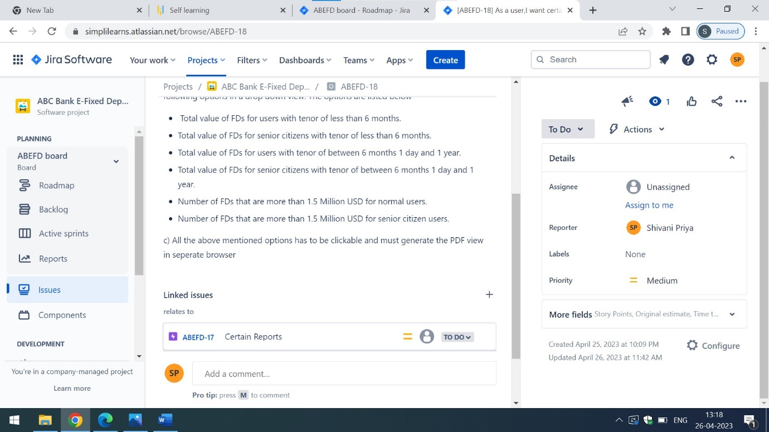

For more detailed information of epics,user stories and acceptance criteria, click on the below mentioned links:

<https://simplilearns.atlassian.net/jira/software/c/projects/ABEFD/boards/10/roadmap>

<https://simplilearns.atlassian.net/jira/software/c/projects/ABEFD/boards/10/backlog?issueLimit=100>